# Instructions to create database in using PGAdmin

The script SQL_Scripts.sql may be able to create the database and even populate it.

Before execute you need to ensure that you have the input files and their path is correct in the script.

1. Charity_data.csv
2. City_coord.csv

Download the files from Git Repository, don’t use your files as I had to remove duplicates and complete around 50 records that were without Lat and Long.

Save the files in your folder data.

Replace the path in the Script to adapt to your workspace

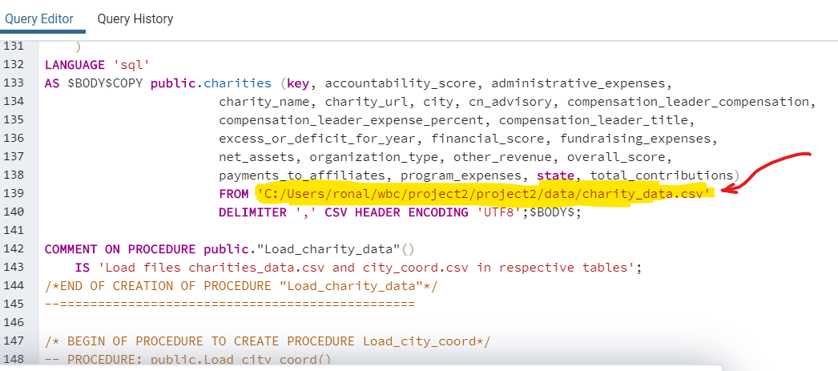

We will use the view in our rotines. The view contains both files. The view name is : charities_view